Life Lessons Multi Media Presents

**Doctor Mother Ruth Rattler Presents** 

**“Sisters of Zion”**

First Class of 2025-2026

**Harvest Time**

**Filling the GAP with Life Lessons**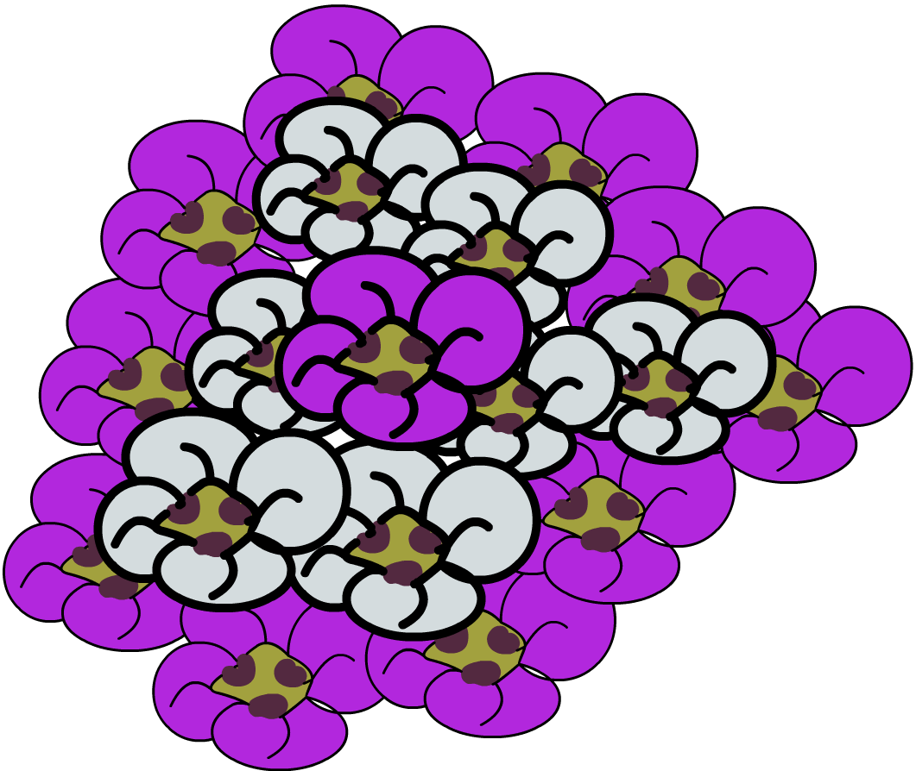

**Skills Conference**

**Minor (CHILD) PHOTO/VIDEO RELEASE FORM**

I _____________________________, THE PARENT OR LEGAL GUARDIAN OF _________________________________ [CHILD] GRANT LIFE LESSONS MULTI MEDIA THE PERMISSION TO USE THE PHOTOGRAPHS/ VIDEO DESCRIBED FOR ANY LEGAL USE, INCLUDING BUT NOT LIMITED TO PUBLICITY, COPYRIGHT PURPOSES, ILLUSTRATIONS, ADVERTISING AND WEB CONTENT, DURING THE TIME PERIOD Allotted time to complete the documentary series.

PARENT/GAURDAIN SIGNATURE___________________________________________

DATE__________________

PARENT/GAURDIAN SIGNATURE___________________________________________

CHILD’S NAME_________________________________________________

PHONE NUMBER________________________________________________

Sign and email back to Kyoungfullsail@gmail.com